Disclaimer: These are basic instructions only and not detailed enough to provide complete instruction for each of the sequences. These summaries are to be used only as a quick reference guide. You are recommended to see a Lymphedema Therapist for more detailed instruction for your own personal diagnosis. Please discuss all contraindications and precautions with your Doctor or Lymphedema Therapist prior to commencing self-MLD.

SELF MLD EXAMPLE: LEFT BREAST CANCER SURGERY/RADIATION
(for RIGHT Upper Extremity do the reverse)

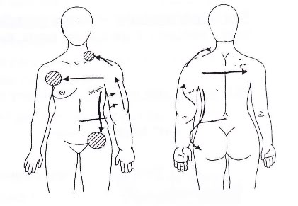
Self-MLD sequence for the LEFT UPPER EXTREMITY

The goal is to activate the lymphatic system and move edema fluid from the affected left upper extremity to the axillary lymph nodes (arm pit) of the unaffected right side and the inguinal (groin) lymph nodes of the left side.
Repeat each step as often as desired. This self-treatment may take 25-30 minutes but can be shortened or extended as necessary. Even 10 minutes of trunk treatment will be beneficial.
Abdominal preparation
- Start with alternating pressure and release on the various sections of your abdomen.
- Perform deep abdominal breathing with assisted hand pressure.
Neck preparation
- Perform shoulder circles.
- Perform side-to-side head and neck stretches.
- Perform side-to-side head & neck turns.
- Clear the affected area above the collar bone with stationary circles.
Trunk preparation
- Clear the unaffected axillary lymph nodes (right arm pit) with circular movements.
- Clear the unaffected, right chest area with stationary circles.
- Move skin over the breast bone from the affected to the unaffected side.
- Move fluid from the affected left upper quadrant toward the right unaffected side.
- Prepare the inguinal (groin) lymph nodes with stationary circles.
- Move fluid down the affected side of your trunk toward your groin using stationary circles.
Arm treatment
- Move fluid from your affected shoulder to the area above the collar bone, gradually incorporating more of your upper arm including the inner side. Always push fluid toward your shoulder and beyond, e.g. toward the pre-treated, unaffected side, and down to the groin lymph nodes.
- Perform stationary circles in the affected axilla (arm pit). CAUTION: Check first with your primary therapist to make sure this is an appropriate technique for you!
- Treat the inner side of your upper arm with your arm over your head using stationary circles all the way down to the inguinal (groin) nodes and across the axilla (arm pit).
- Treat the inner and outer sides of your elbow with stationary circles. Follow up along the entire area with stationary circles as desired.
- Treat the inner and outer sides of your forearm with stationary circles.
- Treat your wrist and fingers with stationary circles, using your whole hand and/or finger tips as desired.
- Follow up with stationary circles across your front and down toward your groin while using deep, diaphragmatic breathing techniques.

